***New flower pattern - Spring butterfly wings***

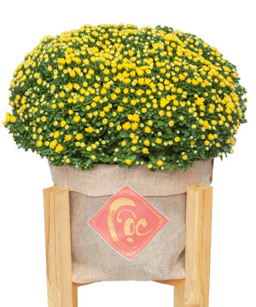

*"Welcome spring with color and luck with a pot of pink phalaenopsis. Orchid pots are suitable for decorating homes with small spaces but still increase the coziness and elegance of the room space.*